**高雄醫學大學華語文中心**

**Kaohsiung Medical University Chinese Language Centre**

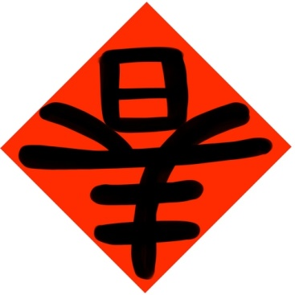 你對中國新年的習俗有興趣嗎？

你想自己寫春聯、剪紙嗎？

歡迎參加我們的活動！（我們提供午餐）

Are you interested in customs of Chinese New Year?

Do you want to write your own Spring Festival couplets and design special pattern of Chinese Paper Cutting?

Please join us! (Lunch provided)

Date日期：2016/2/4 星期四 Thursday

Time時間：10:00~12:00 AM

Place地點：CS201

Organizer主辦單位：Chinese Language Center華語文中心

🞏 我要參加，我叫_________________。

Yes, I want to join it. My name is ____________________。

🞏 謝謝，下次吧！

No, Thank you. Maybe next time

★如果你想參加，請把報名表e-mail至：[wylu@kmu.edu.tw](mailto:wylu@kmu.edu.tw)

If you would like to participate this activity, please email your application form to this e-mail address: [wylu@kmu.edu.tw](mailto:wylu@kmu.edu.tw)

